5 -Classification
Classification
1. Introduction to Module 5
▶️ Introduction to Module 5 (0:45)
Welcome to the fifth week of the course, Machine Learning for Data Science. This week we're going to cover the topic of classification. So remember that in classification problems, our task is to predict an output that is categorical. Meaning, it's one of several labels instead of a numerical value, which was the case for regression. We're going to start the week by describing the setup of classification problems, and then we'll move on to our first technique for classification, which is the logistic regression. So let's move into it.

▶️ Classification (8:02)
Welcome back. In this chapter, we're going to talk about Classification Problems. So far we've been talking about regression problems in which the output variable associated to a given input x is a number. In the classification setup, the outputs are going to be labelled. Let's go into a formal definition of this labels. In particular, we will consider a discrete set C, essentially a set of elements. These elements are going to be K class labels, meaning the labels that we can assign to particular inputs. And in this context, the output variable Y is going to be qualitative. And it's going to take a value from the set C, our goal is to build a classifier C of x that assigns a class label C to an input x. In other words, this function C is going to map elements in R^p meaning p dimensional vectors of inputs. Into a discrete set of labels, C. Examples of these problems are image classification. So in that particular scenario, what we're going to have is an image of maybe dogs and cats. So in particular, we will have that C would be dog, cat. The input x will be a vector of features extracted from these images. Essentially, from an image you will decide what features you want to plot into your classifier, is going to be a p dimensional vector.
You will fit this vector into a classifier. And the classifier will tell you if this image corresponds to a dog or a cat. Notice that the classifier will get some images right and some images wrong. So this will induce errors that we will analyze later on.
In order to study classification problems from mathematical point of view, we're going to consider what's called a generative model. In a generative model, we're going to have a data set D of inputs and outputs. And we're going to assume that these points are generated according to the following two steps. In our first step, we're going to randomly sample an input xi from a marginal distribution f of X.
Once we have a realization of the input xi, we are going to assign an output label yi to this input using a conditional PMF, probability mass function. This PMF is defined in the middle of this equation.
Essentially what this probability is telling you is the probability that the output take a particular label k contained in the set C. Given that we know the input vector xi. We're going to define this conditional probability using the function Pk of xi. And we're going to call this function, the conditional class probability. In other words, this function will tell us what's the probability that the output of a particular input X is a level K.
Let's illustrate these two steps with a particular numerical example. In this example, we're going to generate 100 sample points according to the following distributions. So first we're going to assume that x is distributed according to a uniform distribution between -2 and 2. So this is fx of x, mentioned in the previous slide, and our conditional class probability Is given in this particular formula.
So let me generate a hypothetical number, according to these two distributions. So in the first step, we're going to sample an input X, according to this uniform distribution. So imagine that we have a random number generator, able to generate numbers uniformly between -2 and 2. We get that, for example, our first sample has a value of 0.44. Just a random number in the interval -2 to 2.
Once we have this realization for the first input in our data set. We're going to look at Into the conditional class probability evaluated at that particular point.
So we have that p of x1 is going to be p evaluated at 0.44. And this will provide two values, these values are approximately 0.70 for the label k equal to 1. And see 0.30, for the label k equal to 0. In other words, we're going to flip a coin, with a bias 0.70. If that coins comes head, we will assign a label 1, to the input x1. And with a 30% probability, we will assign a label 0 to the input x1. So imagine that we flip this coin and we get a label k equal to 1. So in that particular case, y1 will be equal to 1, and the first sample in our data set will be equal to the point 0.44, x1 with a label 1. We can keep generating samples, so let's do a second one for clarity.
So repeating the process, we're going to first choose a random number in the uniform distribution -2 and 2. So imagine that in this case, we get a value x2, the input of the second sample, to be -1.1. In there, using that value, we will look into Pk(x2). And plugging in the value 1.1 we will obtain the probability of getting a label, k=1 is going to be roughly 0.1. Therefore, with a 90% probability, we will get a label 0. Again, we flip a coin with those biases.
And we will obtain, for example, a label 0. So notice that I'm not picking the largest number, I'm flipping a coin with those biases. In this particular case the bias for 0 is so high that I'm going to assume that the output is equal to 0. So our second data point will be an input -1.1 and an output 0. So we'll keep repeating this 100 times and then we'll fill a dataset. And this is how we generate the cloud of points in this figure. So I'm going to clean up the screen.
So essentially, in this data set, we have points where the input X is in the interval -2 to 2 and the output Y takes value 0 or 1. These are the blue dots in this image, the gray function in the middle is equal to a graphical representation of this function on the top. So this is called a sigmoid function and essentially is a function that a 0 takes a height of 0.5 and then monotonically increase in this form.
Look at this function, we observe that when the function takes values close to 1. The concentration of outputs that are around 1 is going to be high essentially will have very few values that are 0. And when the function takes low values close to 0, the outputs of the corresponding inputs will be mostly 0s, even though we'll have some 1s.
1 Attempt Quiz: Classification

這段教材的核心是在介紹機器學習中的「分類問題 (Classification Problems)」，並用一個數學上的「生成模型 (Generative Model)」來解釋數據是如何產生的。
核心觀念 1：什麼是分類問題？
在這之前，你學的可能是迴歸問題（Regression），也就是預測一個「連續的數字」（例如：預測房價、氣溫）。
而分類問題的目標，是預測一個「類別（標籤）」。
- 類別集合 C：包含所有可能的標籤。例如：C = \{貓, 狗}，這裡有 K=2 個類別。
- 輸入值 x：特徵向量（例如：一張圖片中提取出來的特徵，像是有沒有鬍鬚、耳朵形狀等，表示為 p 維向量）。
- 分類器 C(x)：我們的目標是建立一個數學函數（分類器），把輸入的 x 丟進去，它就會吐出一個標籤（貓或狗）。
💡 小結：分類器就像一個分類機器，吃了特徵 x，吐出標籤 y。它有可能猜對，也有可能猜錯。

核心觀念 2：什麼是生成模型（Generative Model）？
為了解析分類問題，科學家會假設數據是透過一個「兩步驟的生成模型」產生的：
- 第一步：隨機抽取輸入值 xi
從一個整體的機率分佈 f(X) 中，隨機抽取出一個樣本的特徵 xi
- 第二步：根據 xi，擲骰子決定標籤 yi
利用條件類別機率（Conditional Class Probability） Pk(xi)，算出在這個 xi 條件下，它是各個類別的機率是多少，然後像擲硬幣/骰子一樣決定最終標籤。

核心觀念 3：數字範例與 S 型曲線（Sigmoid）
一個具體的數字例子來跑完上述的兩個步驟，總共重複了 100 次來製造出 100 筆數據。
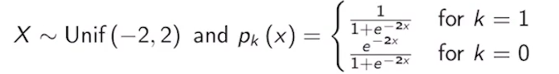
🎲 第一次抽樣實驗：
- 步驟一：從 -2 到 2 的均勻分佈中隨機抽一個數字，抽到了 x1 = 0.44
- 步驟二：把 0.44 代入一個特定的公式（Sigmoid 函數），算出來的結果是：
  - 標籤為 1 的機率是 70%（0.70）
  - 標籤為 0 的機率是 30%（0.30）
- 結果：拿一枚「70% 機率是正面」的作弊硬幣來丟。丟出來是正面，於是這筆數據的標籤 y1 就被定為 1。我們得到了第一筆資料：(0.44, 1)
🎲 第二次抽樣實驗：
- 步驟一：重新抽樣，這次抽到了 x2 = -1.1
- 步驟二：把 -1.1 代入公式，發現：
  - 標籤為 1 的機率只有 10%（0.1）
  - 標籤為 0 的機率高達 90%（0.90）
- 結果：丟硬幣，因為變成 0 的機率極高，最後丟出來的結果是 0。我們得到第二筆資料：(-1.1, 0)
📈 數據分佈的圖形規律：
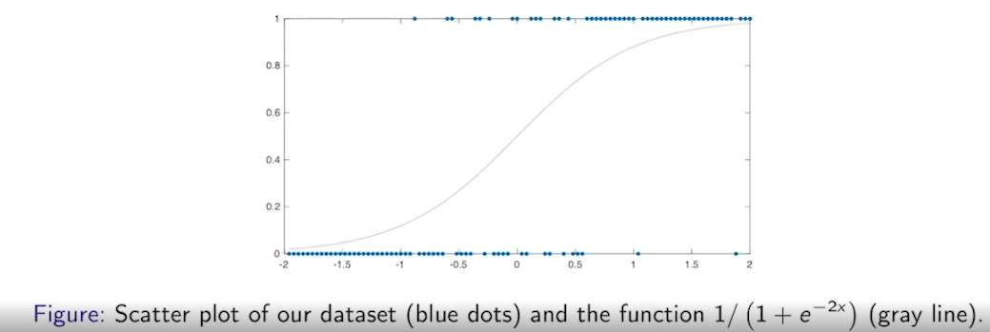
把這個過程重複 100 次，畫在圖表上（如上圖）：
- X 軸是輸入值（-2 到 2 之間）。
- Y 軸是標籤（只有 0 和 1 兩個高度，形成藍色點點陣營）。
- 中間那條灰色的曲線就是 Sigmoid 函數（在 x=0 時高度是 0.5，並向兩邊延伸）。
觀察到的現象：
- 灰色曲線很高（接近 1）的區域：產生的資料點幾乎都集中在 y=1 的高處，極少出現 0。
- 灰色曲線很低（接近 0）的區域：產生的資料點幾乎都集中在 y=0 的低處，極少出現 1。

總結
這段話是用數學的視角幫你建立世界觀：「我們在現實中看到的數據（點點），其實背後都藏著一個機率函數（灰色曲線）。機器學習（分類器）的任務，就是透過觀察這些點點，把背後那條隱藏的灰色曲線給找出來！」

▶️ Bayes Classifier and Local Averaging (8:47)
When we have stated the classification problem and we explained how we have generated our data set, we're going to define what's called the Bayes Optimal Classifier C of x. The definition is in the expression below. What this definition is telling you is that for a particular given input x, we're going to look at all possible values of k of the conditional class probabilities and we will find that label k that maximizes the conditional class probability. In other words, given an input x, the BOC, the Bayes Optimal Classifier, assigns a label k that maximizes the conditional class probability. We will see later on that this classifier minimizes the classification error rate, which is a measure of the quality of the classifier. Let's look into the example in the previous slide to find an explicit form for this Bayes Optimal Classifier. Going back to the previous slide, we observe that the function P_1 of x is given by that gray plot. We also have that P_0 of x, given in this expression here, is equal to 1 minus P_1 of x. This is something that's always true for binary classification problems because the probability of getting a zero should be 1 minus the probability of getting a one. Therefore, if we plot the function 1 minus P_1, you should obtain a curve that's very similar but somehow symmetric to the gray line. Essentially, I'm going to have a function that still passes through that middle point, essentially the middle point, where x is equal to zero and y is 0.5, and the function will be a symmetric sigmoid of this form. Now, according to the definition of the Optimal Bayes Classifier, for any value of x, we will assign a label C of x corresponding to the largest conditional class probability. For example, for this particular value of x in here, the values of the conditional class probability C is, this value here for the class 1 and this value here for the class 0. Since the class 0 provides a larger value for that value of x, we will classify that point with a value zero. This is going to be true for all the points x in this region, in particular, when x is less than zero. In contrast, for values of x above zero, an evaluation of the conditional class probabilities will show you that P_1 will always be greater than P_0. Therefore, we will assign a label 1 to all the points x greater or equal than zero. The point at zero, you can arbitrarily assign it to any class. Going forward, we can have a more formal statement of what I mentioned before. Essentially, since P_1 is greater or equal than P_0 for x greater or equal than zero, the Bayes Optimal Classifier will take a value 1 for x greater or equal than zero, and zero otherwise meaning x less than zero. Now, in practice, there is a limitation to apply this logic because we typically do not know the conditional class probabilities that have been used to generate a data set. In practice, we're given the data set, but we're not given the generative model. The same way that when we're dealing with a linear model, we're given a data set, but we're not given the parameters Beta 0, Beta 1, up to Beta p, that nature is using to generate these points. In other words, only nature knows how the data set is generated, but we cannot look into that generative process. That's a black box for us, we cannot access the parameters inside the generative process. A possible approach to solve this issue is by using Local Averaging. Let me show you how Local Averaging works in the data set that I showed you before, so let's go back to slides. In this slide, if I clean things up, Local Averaging would work as follows. I want to estimate P_1 and P_0 for a particular value of x. Let's choose a particular value of x, maybe a value of minus 0.2. I'm going to pick a window of a particular width. For example, values within minus 0.4 and zero. Essentially, minus 0.2 would be the middle of the window and you will move zero two units to the right and to the left, and now I'm going to focus on the window induced by those two values and we'll count the number of ones and the number of zeros in that particular window. The definition of P_1 of x at that particular value of x, meaning P_1 of minus 0.2, will be equal to the fraction of ones contained in the set of points included in that window, and P_0 of minus 0.2 will be the fraction of zeros that are contained in that particular window. Going back to this figure, this is essentially what I obtained in that particular blue plot. You can see that by performing a Local Averaging, I obtain a numerical function represented in blue, that is a descent approximation of the gray curve, which remember, is equal to P_1 of x. We can call that blue function P_1 hat of x, since it is an approximation of P_1 of x. This P_1 hat of x is something that we can compute from data, but P_1 of x, it's something that's completely hidden to us, so we will not know this gray line. Once we have computed P_1 hat of x, we can now find an approximation of the Bayes Optimal Classifier, which I'm denoting here by C hat. The rule for this classifier is exactly the same as the one we had before, meaning when P_1 hat of x is greater or equal than P_1 zero of x, we will assign a class 1 to that particular input. In this case, the current value for the classifier is not exactly a zero, which was this value before, but it's slightly higher than zero. But you can see that for any point beyond this particular value, we will assign a value C of x equal to one and for points below that particular threshold value, we will have an Optimal Bayes Classifier, so I have to include a hat in there, equal to zero. Now, remember that Local Averaging is not a technique that's new to us. In particular, this is something that we talked about when we describe a genetic regression problem. In particular, we could solve our regression problem if we have a very large data set by looking at the outputs corresponding to the inputs that are close enough to a point for which I want to perform regression. Also, you should remember that in that particular situation, something called the Curse of Dimensionality come onto the table and this is something that's going to happen here too. Essentially, when x is a high dimensional input vector, doing Local Averaging does not provide a reliable estimate of the conditional class probabilities. For the same reason, that performing Local Averaging is not a good solution to regression problems in the high dimensional setup. In particular, in high dimensions, all input points are very far from each other, and we will not be able to find points that are close enough to the input vector for which we want to perform a classification. Therefore, if we want to count the number of points of different classes that are contained within a given ball centered around the point x for which we want to perform classification, we will not have enough points to perform a reliable counting. To overcome this issue, we will resort to a structure model, which is the same approach we took for regression problems.

1 Attempt Quiz: Bayesian classifier and Local Averaging
這段教材進入了機器學習分類問題的核心，並帶出了兩個非常重要的觀念：貝氏最佳分類器（Bayes Optimal Classifier） 以及如何用局部平均法（Local Averaging）在現實中去逼近它。同時，它也點出了高維度數據下的致命傷——維度詛咒（Curse of Dimensionality）。

觀念 1：上帝視角的「貝氏最佳分類器 (Bayes Optimal Classifier, BOC)」
一個分類器叫做「貝氏最佳分類器」。它的邏輯非常簡單粗暴：
「在某個輸入值 x 下，哪一個類別的機率最高，就把 x 分給那類別。」
以二元分類（只有標籤 0 和 1）為例：
- 我們知道標籤 1 的機率是 P1(x)（那條灰色 S 型曲線）。
- 那標籤 0 的機率必然是 P0(x) = 1 - P1(x)（一條對稱的曲線）。
決策邊界（Decision Boundary）是如何劃分的？
- 當 x < 0 時：看圖會發現 P0(x) 的曲線比 P1(x) 還高（機率大於 0.5）。所以貝氏最佳分類器會把這個區域的所有點都歸類為 0。
- 當 x ≥ 0 時：P1(x) 的曲線比較高。所以分類器會把這個區域的所有點都歸類為 1。
- 分界點 x = 0：此時兩邊機率都是 0.5，分類器隨便猜哪邊都可以。
📌 貝氏最佳分類器的核心定理：數學上可以證明，這種「誰機率大就選誰」的分類器，能夠讓分類錯誤率（Error Rate）達到最低。它是理論上的極限、完美的化身。
⚠️ 現實的殘酷限制：這種完美分類器只有「上帝（大自然）」知道。在現實中，我們手上只有一堆數據點，我們根本不知道背後那條灰色的機率曲線（Generative Model）長怎樣。這就像一個黑盒子。
觀念 2：現實中的救星——局部平均法 (Local Averaging)
既然我們不知道真正的機率曲線 P1(x)，那該怎麼辦？課文提出了一個直覺的方法：局部平均法。
假設我們想估計在 x = -0.2 這個位置的機率：
- 畫一個窗格（Window）：以 -0.2 為中心，左右各擴展 0.2 單位，圈出一個 [-0.4, 0] 的區間。
- 數人頭（算比例）：數數看這個窗格裡掉進了多少筆資料。
  - 假設裡面有 10 個點，其中有 3 個點的標籤是 1，7 個點的標籤是 0。
- 得到估計值 hat{P1}(x)：我們就說在 x = -0.2 的地方，得到 1 的估計機率 hat{P1}(-0.2) = 3/10 = 0.3（戴上帽子 hat{P} 表示這是從數據「估計」出來的，不是大自然真正的機率）。

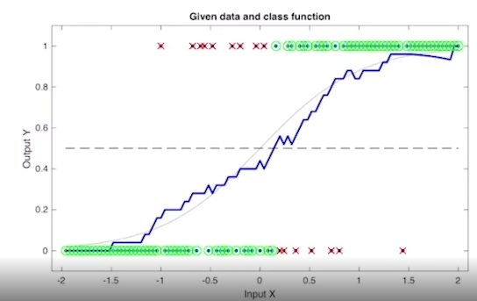
當你把每一個 x 點都用這種「局部圈點算比例」的方式跑過一遍，就會得到圖中那條藍色的折線 hat{P1}(x)。
- 藍色折線雖然扭曲、不完美，但它非常成功地逼近了那條大自然隱藏的灰色曲線！
- 接著，我們利用藍色曲線來做新的分類器 hat{C}(x)：藍色高度高於 0.5 就猜 1，低於 0.5 就猜 0。這時算出來的分界點可能不是剛好等於 0，而是稍微偏右一點點，但已經非常接近完美的貝氏分類器了。
觀念 3：大魔王關卡——維度詛咒 (Curse of Dimensionality)
局部平均法聽起來很完美，為什麼我們不一直用它就好？因為當我們的輸入特徵 x 從 1 維變成高維度（例如 p 維向量，包含幾百個特徵）時，會遇到維度詛咒。
什麼意思呢？
- 在 1 維空間（一條線）：點和點之間很容易擠在一起，你隨便畫個圈（窗格），裡面都能抓到好幾筆資料來算比例。
- 在高維空間（想像一個超巨大的多維球體）：空間幾何級數放大，所有的數據點會變得極度稀疏。每個點和每個點之間都離得非常非常遠。
當你想在某個 x 點周圍畫一個球體（窗格）來數人頭時，你會驚恐地發現：「球體裡面竟然空空如也，連一筆資料都沒有！」 既然連資料都沒有，你就無法計算標籤 0 和 1 的比例，局部平均法當場宣告失效。
💡 總結與下一步
這段課文的承上啟下非常精彩：
- 理想：我們想要找到「貝氏最佳分類器」（看機率決定分類）。
- 現實方法：我們嘗試用「局部平均法」（看鄰居的標籤比例）來模仿它。
- 遇到困境：如果特徵太多（高維度），局部平均法會因為「維度詛咒」而崩潰。
- 解決方案（下一章的伏筆）：為了解決高維度抓不到鄰居的問題，我們不能再依賴這種局部的點點計數了，我們必須引進「結構化模型 (Structured Model)」（例如：邏輯斯迴歸 Logistic Regression，或是線性判別分析 LDA），強行用一個數學結構去套在數據上。

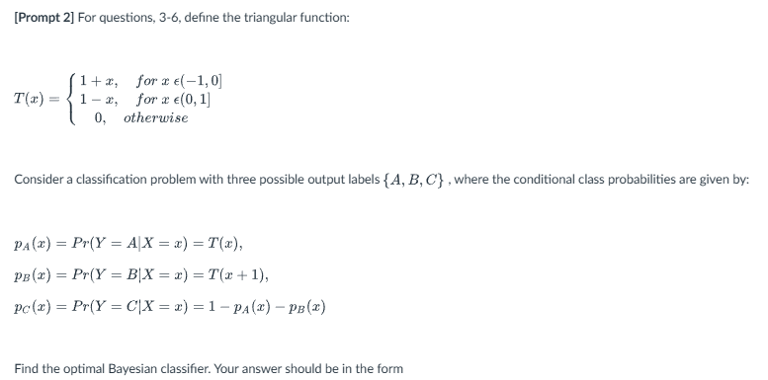
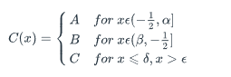
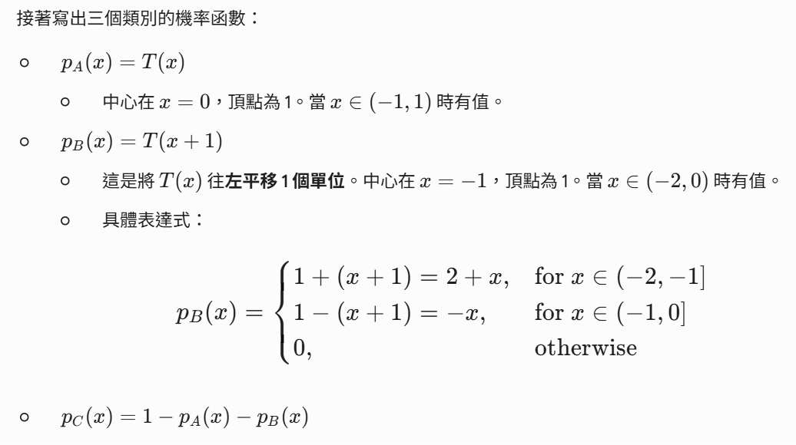
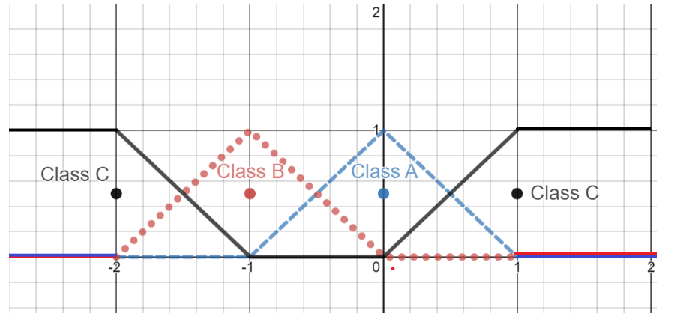
3. Logistic Regression
▶️ Logistic Regression (4:54)
In the previous video, we have seen how the cause of dimensionality does not allow us to perform local averaging in only to faithfully estimate the conditional class probabilities for a given data set. Therefore we need to resort to parametric models. One of this parametric models, it's what's called a logistic function. In the case of logistic functions, we're going to consider a binary classification problem where the classes are zero and one, and for now we're going to consider that our inputs are one-dimensional. Essentially, p is equal to 1, therefore, our input is just a scalar value. The particular parametric representation of the conditional class probabilities are given below. In particular, the probability that the label is one, given the input x, is going to be a function parametrized by Beta_0 and Beta_1, and is given by the expression on the right. Essentially, we are going to have an exponent to the power of something that should remind you of a linear regression divided by 1 plus the same exponent. This is what we call p_1, the conditional class probability for the class 1. Again, this function is going to be parameterized by Beta_0 and Beta_1. We also have that the conditional class probability for the class 0, essentially is the same expression as p1, but the numerator instead of an exponent is equal to one. You should realize that the probability that the output is one plus the probability that the output is zero should sum to one since these are the only two possibilities as outputs. You should notice that the sum of these two functions, the conditional class probabilities for zero and one are going to sum to one. I invite you to verify this. Now, what is the shape of this function here? This function is called a sigmoid function, and we can study its shape by looking at some particular examples. For example, let's consider for simplicity that Beta_0 is equal to zero and Beta_1 is equal to one. In that case, that sigmoidal function is going to be e_x divided by one plus e_x. Now, if we look at how this function P_1 of x as a function of x, we are going to get the following form. So if we evaluate the function at x equal to 0, we're going to get that e_0 is equal to 1 divided by 1 plus e_0, which is 1. So what we want to obtain a value of one-half. When x goes to infinity, e_x will grow to infinity and in the denominator, e_x will dominate the one, therefore this will converge towards one. So for x going to infinity, we're going to have an asymptotic value that will go towards one this way. In contrast, when x goes to minus infinity, e to the minus infinity will converge to zero, and we will obtain 0 divided by 1 plus 0, essentially this will converge asymptotically towards zero. So we're going to have a function that converge towards zero this way. Let's now increment the value of Beta_1 from 1-2. In that case, P_1 of x will look like this. Through a very simple analysis, you can convince yourself that what this increment in the exponent really is doing, is accelerating the rate of growth and the rate of decrease of this function. So we are going to get an s-shape function, therefore the word sigmoid is going from Sigma in Greek, and the shape of the sigmoid function will be changed when you change the value of Beta_1. If instead of changing the value of Beta_1 from one to two, we change it to something like one-half, meaning less than one. The function P_1x would look like this, and sigmoid function could increase much slower, so it will be much flatter. So essentially we can tune the rate of growth of the sigmoid by changing the value of Beta_1. Now, what's the effect of Beta_0? You can also convince yourself that the value of Beta_0 will be able to shift this function to the right and to the left. Therefore, the two parameters, Beta_0 and Beta_1 will allow you to one, tune the rate of growth of the sigmoid function and two, shift that sigmoid function to the right or to the left.
1 Attempt Quiz: Logistic Regression

這段教材解鎖了機器學習中最經典的分類模型之一：邏輯斯迴歸（Logistic Regression）中的核心數學工具——邏輯斯函數（Logistic Function，又稱 Sigmoid 函數）。
為了躲開「維度詛咒」，我們不能再用局部平均法去數人頭了，必須直接給出一個參數化模型（Parametric Model）。以下為你梳理這段內容的三大精髓：
1. 邏輯斯函數的數學結構
在二元分類（標籤為 0 或 1）且輸入只有一維（x 是個純量）的設定下，我們用 β0 和 β1 兩個參數來強行規定機率的公式：
- 當標籤為 1 的條件機率 P1(x)：
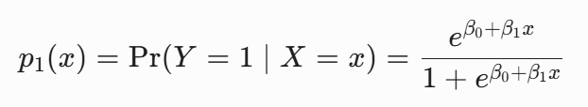
💡 這公式怎麼記？ 分子是 e 的「線性迴歸公式（β0 + β1 x）」次方；分母則是 1 加上分子。
- 當標籤為 0 的條件機率 P0(x)：
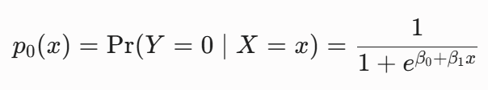
🧩 動腦小思考：把這兩個公式相加，分母相同，分子變成 e^{β0 + β1 x} + 1，剛好跟分母消掉等於 1！這完美符合了機率的定義：事情不是發生（1），就是不發生（0），兩者機率相加必須是 100%。
2. 為什麼叫 Sigmoid 函數？
為了看懂這個函數的長相，我們假設一個最乾淨的狀況：讓 β0 = 0 且 β1 = 1。公式會簡化成：P1(x) = {e^x}/{1 + e^x}
我們來觀察當 x 產生極端變化時，圖形會怎麼走：
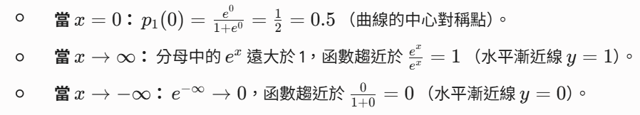把這三點連起來，就會得到一個精美的 「S 型曲線」。因為它長得像希臘字母的 Sigma，所以被命名為 Sigmoid 函數。這個函數最厲害的地方在於：不管你的 x 帶入多大或多小的數字，它算出來的輸出永遠被鎖在 0 到 1 之間，完美契合「機率」的範圍！
3. 兩大參數 β0 與 β1 的操控魔法
有了這條 S 型曲線後，我們可以透過調整 β0 和 β1 來捏塑這條曲線，讓它完美貼合大自然給我們的數據：
🪄 β1 的魔法：控制曲線的「陡峭程度」（成長速率）
- 當 β1 變大（例如從 1 變成 2）：x 的微小變化就會被放大，導致曲線在中間段劇烈上升，變成一條非常陡峭的 S。
- 當 β1 變小（例如變成 0.5）：曲線的上升速度會變慢，變成一條非常平緩、躺得比較平的 S。
🪄 β0 的魔法：控制曲線的「左右位移」
- 改變 β0的數值，可以把整條 S 型曲線往左邊或往右邊推移，決定這條曲線要在哪一個 x 區間開始從 0 爬升到 1。
💡 核心總結
現實中大自然的數據點分佈在各處，我們只要透過數據去訓練（Fit）出最適合的 β0 和 β1，就能擁有一條能量身打造的機率曲線。有了這條曲線，我們就能完美預測任何新進來的 x 變成 1 或 0 的機率是多少了！

1. 核心定義：機率 vs 勝算odds
- 機率（Probability, p）： 指的是「某事件發生的次數」佔「所有可能發生總次數」的比例。
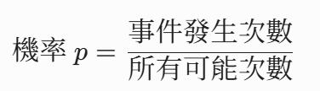
數值範圍絕對在 0 到 1 之間（即 0% ~ 100%）。
- 勝算（Odds）： 指的是「事件發生的機率」與「事件不發生的機率（互補機率）」的比值。
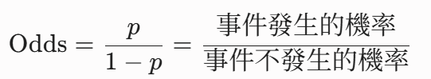
數值範圍是 0 到 正無窮大
2. 生活例子
假設今天有一場棒球比賽，隊伍贏球的機率 p = 0.8（80%）。
那麼輸球的機率就是 1 - p = 0.2（20%）。
這時候，贏球的 Odds（勝算） 計算如下：
Odds = 0.8/0.2 = 4
這代表：「贏球的可能性是輸球的 4 倍」（在賭博或馬報上，常會寫成比率 4:1）。
- 如果贏球機率是 0.5（五五開），Odds 就是 0.5/0.5 = 1（贏與不贏的機會相等）。
- 如果贏球機率極高，例如 0.99，Odds 就是 0.99/0.01 = 99（勝算極大）。
3. 為什麼邏輯斯回歸要大費周章引進 Odds？
這關係到上一題你看到的函數圖形。
在機器學習中，我們希望用一個線性方程 β0 + β1 ∙x 來預測目標。但是：
- 線性方程的輸出範圍是 (-infty, +infty)。
- 而我們想預測的機率 p 範圍卻被死死限制在 [0, 1]
直接拿線性方程去預測機率，模型很容易預測出「機率是 120%」或「機率是 -50%」這種不合邏輯的數字。
解法就是透過 Odds 進行轉換：
- 機率 p 的範圍是 [0, 1]
- 轉換成 Odds = p/1-p 後，範圍被拉伸到了 [0, +infty)
- 如果再對 Odds 取一個自然對數（稱為 Log-Odds 或 Logit 函數）：
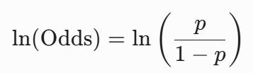
這時候，數值範圍就完美地擴展到了 (-infty, +infty)！
這樣一來，我們就可以用沒有範圍限制的線性回歸公式，去擬合這這個 Log-Odds 了：
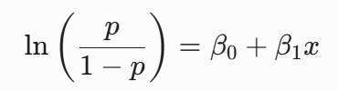
把這個公式反解出來，就會得到你前面影片提到的 Sigmoid 函數。這就是邏輯斯回歸命名與推導的由來！

▶️ Maximum Likelihood (8:06)
Now, given a particular data set for my pairs of inputs and outputs, we would like to estimate the parameters beta 0 and beta 1, that nature is using to generate the data. Remember, we're going to assume in this particular point, that nature is generating the data points, using a logistic function with two particular values for beta 0 and beta 1, which we don't know. Essentially, we're going to observe the data and we would like to estimate beta 0 and beta 1, exclusively from data. To perform this estimation, we're going to use a criterion called the maximum likelihood criterion, that allow us to estimate beta 0 and beta 1, from that alone. Let's assume for now that the set of inputs are given, the likelihood function is defined as the conditional probability, of observing a particular set of outputs given the inputs.
This conditional probability, is given in here for just one pair of points, so essentially, the conditional probability of observing an output yi, given an input xi, is given by this expression. We're going to assume that this conditional class probabilities, are described by logistic functions with parameters, theta 0 and theta 1. So these are essentially two generic values for beta 0 and beta 1. Now, assuming that the points in our data set are generated independently at random from each other, we're going to have, that the probability of serving a whole data set, is going to be equal to the product of these probabilities. So this is coming from the definition of independence. Therefore, the product of all these conditional probabilities, is what we call the likelihood function. Notice that this likelihood function depends only on the unknown parameters, theta 0 and theta 1, since xi and yi are assumed to be given. So the only thing that's unknown, in this part of the equation are zeta 0, and zeta 1. The Xi and the Yi are known. Now we can easily rewrite this equation taking into account, that the expression for the conditional class probabilities are different when the output yi is 1 and when the output yi are 0. So if we go back to the previous slide, when the output y is equal to 1, this is the function that we should use, in contrast, when yi is equal to 0, this is the function that we should use. Therefore, we're going to together all the points yi, for which the output is equal to 1, and all the points yi for which the output is equal to 0, and we're going to separate the products into two terms. This first product, which are essentially the terms in this product for which yi is equal to 1, and the second product, which are the products for outputs equal to 0 in that product.
Also notice and they condition a class probabilities inside this first product, is the one associated with an output 1, and the conditional class probability of the second product, is the one associated with an output 0. So these two expressions are exactly the same thing. Now, once we have a likelihood function, the maximum likelihood estimator is very easy to state. Essentially, our estimates of beta 0 and beta 1 which remember are unknown to us only nature knows them, are going to be the result of maximizing the likelihood function, where zeta 0 and zeta 1 are unknown parameters, and we'll find the values of those parameters, that maximizes this function. Those values, are going to be saved in beta 0 hat and beta 1 hat, and this will be the estimate of the non parameters beta 0 and beta 1. We're going to quickly illustrate this with one example, so this is the default data set. So essentially, the default data set contains a collection of individuals that have borrowed money from the bank, and the bank has historical data of individuals that were able to return the money, and those that were unable to return the money in other words, they defaulted on the credit. In the plot below, we show has blue sphericles individuals that were able to successfully return the money, while the orange crosses were individuals that had to default on their credit. The coordinate of these points are nothing but the balance of those individuals, and their corresponding income. So you can see in this plot that income is not very useful to predict defaults, however, balance is very useful. To understand this, you can focus on a particular income value so we can make a slice in here, and you're going to notice that the fraction of points that were able to successfully and unsuccessfully return that money, are pretty much the same when we shift this window. However, if you focus on balance, you can notice that in the low values of balance, people are able to return their credits, while in the high values of their balance, people are more likely to default on their credit. Therefore, in the following experiment, we will only use balance, as the input to predict the probability of defaulting on your credit. Using the default data set, we get the following coefficients for our logistic regression. Essentially the intercept is going to be beta theta, the balance is going to be beta 1, this is going to be our estimate of beta 0 hat or estimate beta 1 hat, and as we saw in the case of linear regression, the values of beta i hat are random variables. Therefore, there is a standard error, which is nothing but an approximation of the standard deviation, of R estimates beta i hat, so we see that the standard deviation of beta 0 hat is 0.36, and the standard deviation for beta 1 hat is 0.0002. Once we find the values of beta 0 hat and beta 1 hat using, for example, maximum likelihood, we can make predictions about the probability of an individual defaulting, if we know her balance. So in particular, we're going to define p1 hat as a function of the only input balance, so this is essentially the only input we're going to be using. And the shape of this function is exactly a logistic function, where beta 0 and beta 1 are substituted by beta 0 hat and beta 1 hat that we compute from the data set. Now using this function, we can make predictions about the probability of defaulting, meaning the probability that the output is equal to 1, which indicates default, given the balance of an individual.
So for example, if the balance of an individual is $1,000, the probability of defaulting according to the logistic function, will be 0.6%. If the balance of the individual is double that $2,000, then the probability of defaulting jumps up to almost 60%. So this is something that we can look in the previous figure, essentially in here we have that when an individual has $1,000, the probability of defaulting, is much smaller than when the individual has a $2,000 balance.

這段教材將最大似然估計（Maximum Likelihood Estimation, MLE）的數學理論與真實世界中的信用卡違約預測（Default Dataset）案例結合在一起。
這個機器學習中最重要的優化觀念，其中最重要的兩個核心觀念：最大似然估計的數學核心轉換，以及多變數模型下的特徵重要性評估。
核心一：最大似然估計（MLE）的數學推導
我們假設大自然有一組神祕且真實的參數（β0, β1）在控制著資料的生成，而我們的目標是利用手邊已知的數據（xi, yi）來估計出最接近大自然的參數值，記作 hat{β0} 與 hat{β1}
當我們擁有一個包含許多樣本的資料集時，根據樣本之間的獨立性（Independence），整個資料集的聯合機率（Likelihood Function L(θ0, θ1)）是所有單一觀測機率的連乘積。
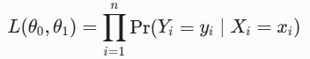
因為當真實標籤 yi = 1 與 yi = 0 時，模型所套用的條件機率公式形式不同，因此可以將連乘積式子依據 yi 的數值拆成兩群：
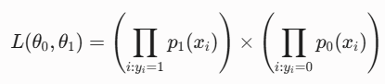
註：在實務上，為了把麻煩的「連乘」變成容易計算的「連加」，我們通常會對似然函數取自然對數，並加上負號，轉化為最小化交叉熵損失函數（Cross-Entropy Loss）。

我們尋找參數的原則非常直覺：「哪一組參數 (θ0, θ1) 讓目前這組既定事實的數據出現機率最高，它就是最好的估計值。」
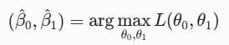
核心二：信用卡違約案例分析（Default Dataset）
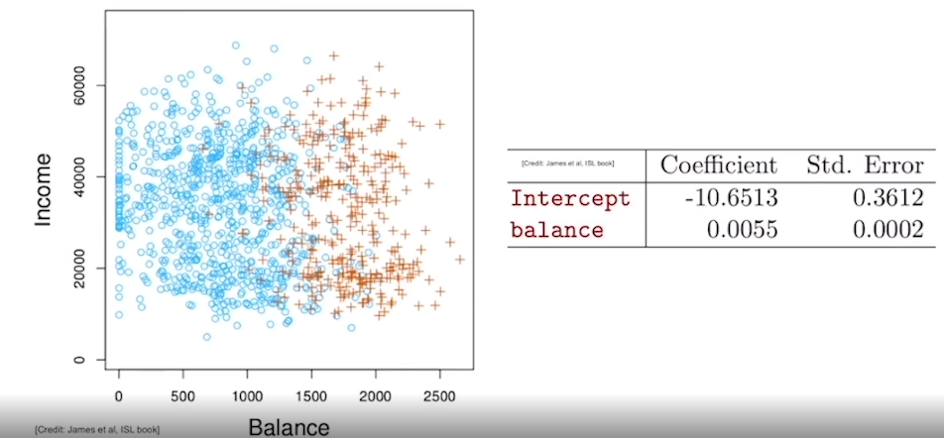
一個非常經典的銀行授信評估案例：透過客戶的「年收入（Income）」與「信用卡帳戶餘額（Balance）」來預測是否會發生債務違約（Default, y=1）。
1. 特徵篩選的洞察
- 收入（Income）： 當你對不同的收入區間做切片（Slice）時會發現，不論收入高低，違約（橘色叉叉）與按時還款（藍色球球）的比例幾乎沒有變化。這說明收入對於預測違約沒有顯著的解釋力。
- 餘額（Balance）： 趨勢非常明顯。低餘額區間內幾乎全是藍色球球（按時還款）；當餘額變高時，橘色叉叉（違約）的密度急劇上升。這說明餘額是一個關鍵的預測特徵。
2. 非線性預測的威力--估計結果與機率預測
利用最大似然估計法，我們只用 Balance 作為輸入 x，計算出了參數的估計值 hat{β0}（截距）與 hat{β1}（Balance 的係數）。
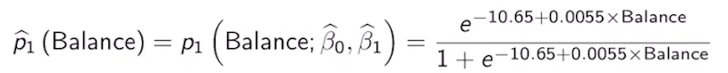
得到模型 hat{p1} (Balance) 後，將不同的數值代入 Sigmoid 函數中，我們能看到機率發生了非線性的躍升：
客戶信用卡餘額 (Balance) | 預測違約機率 hat{p1}​​ | 業務風險評估
$1,000 | 0.6% | 極低風險，安全客戶
$2,000 | 58.6% | 風險飆升，高度危險客戶
這個例子完美體現了 Sigmoid 函數的威力：餘額雖然只增加了一倍（從 $1,000 到 $2,000），但由於 S 型曲線在中段的成長速度極快（由 hat{β1} 控制），導致違約機率直接飆升了將近 100 倍。 這能幫助銀行進行非常精準的風險控管。

▶️ Hypothesis Testing in Logistic Regression (8:03)
In this video, we are going to revisit the concept of hypothesis testing.
In particular, we will use hypothesis testing to decide if a particular input influences an output variable.
Remember that in our learning process, we do not have access to the true value of beta 0 and beta 1. We only have access to the data generated by nature. Therefore, we will not be able to definitely know if beta 1 is equal to 0, which would be the case when the input does not influence the output. Also remember that our estimate beta 1 hat that will tend using maximum likelihood estimation is a random variable because it depends on the random data set collected from nature.
It turns out that this random variable is some bias, therefore, when beta 1 is equal to 0, this random variable is centred around 0. Also the standard deviation of this random variable can be computed from data.
Therefore, once we have a data set, we will be able to compute the standard deviation of this random variable, as well as a particular realization of beta 1 hat.
Using these two values we can now compute the value of z1, as the fraction of beta 1 hat, divided by the standard deviation.
It's easy to prove, that since beta 1 hat is normally distributed, z1 is also a normal distribution centred at 0 whose variance is normalized to be equal to 1.
Do you remember, this distribution contains 95% of its mass in the interval -2 to 2? So essentially, the area below the Gaussian distribution will be 0.95. This tell us that the probability that the absolute value of z1 is less than 2 is going to be 95%. Therefore, if the absolute value of z1 is greater than 2, then we have a statistical evidence to reject the null hypothesis, which in this case is that the input does not influence the output.
We can illustrate this idea using the default data set that we saw in the previous video.
In this particular case, we have a single input, meaning the balance of an individual to predict his or her probability of default
using maximum likelihood estimator, we can compute the values of beta 0 hat and beta 1, hat which are contained in this first column.
The standard deviations can be computed using any statistical software package. And these are the values that we obtained. The theoretical computation of these values had to be on the scope of this course, but any software will provide you with these values.
Now dividing the first column over to the second column, we will compute the Z-statistics. And I've said that in this case, the value of the Z-statistics add in absolute value greater than 2. Therefore, we don't have statistical evidence to reject the hypothesis that the input does not influence the output. In other words, balance is relevant to predict the probability of default.
In the case of dealing with multiple variables, meaning when p is greater than 1, we can use the multivariate logistic function which is defined below.
So in here we have the conditional class probability for class 1. Instead of having two parameters, as we have for p equal to one, we're going to have p plus one parameters beta zero to beta p. The shape of this function is very similar to the one we saw before. The only difference is that the exponents in the function is going to take the form of a linear regression with the inputs. Essentially we're going to have beta 1 x1 + beta p xp + an intercept beta 0. So as we did in the previous examples, we're going to assume that nature is generating points according to this conditional class probability, but the values of betas are something that are not known to us. In other words, beta 0 up to beta p are something that are unknown to us.
Using an available data set, we can use maximum likelihood estimation to compute estimates of those values.
Once we have these estimates, we can make predictions using an approximation of the conditional class probability, which has the shape of the multivariate logistic function, where we substitute the values of beta 0 to beta p, which are unknown to us, to the estimated values beta 0 hat to beta p hat.
In the table below, we're going to use the default data set. But in here instead of considering a single input, which in the previous example was balance, we're going to consider three different input features for each individual, which are the balance, the income, and a categorical variable indicating if this individual is a student or not.
We can deal with a categorical value the same way as we did in linear regression. Essentially you should define a dummy variable x3, which will take the value 1 if this individual is a student and zero otherwise. Once you introduce this dummy variable, you can run the maximum likelihood criterion, which in the multivariate case, will be formally equivalent to the one that we saw for p equal to one. In particular, the likelihood function will be a function of the parameters theta 0 to theta p, which are generic parameters that are used in the linear function included in the exponent. And this likelihood function will be equal to the product of the conditional probability that the output is one, corresponding to those inputs,
times a second product over the points for which the outputs are equal to zero. And again, we multiply the conditional class probabilities for those input points using the class 0.
Notice again, that given the inputs exercise, this product turns out to be a function exclusively of the unknown parameters theta 0 to theta p. And finding the maximum of that function will provide us with the estimate beta 0 hat to beta 2 hat. According to this procedure, and using the default data set, we will be able to find this estimate for beta 0 hat up to beta 3 hat.
Also a standard statistical software package will allow you to compute the standard deviations of the beta hats, which remember that's always random variables. Dividing the first and second column, we will obtain Z-statistics. And notice that the Z-statistic associated with beta two hat is an absolute value less than two.
Therefore, the null hypothesis cannot be rejected.
This indicates that this second variable income is not relevant to make predictions about the probability of defaulting.
Also I'd like to remark that once you remove the second variable, you will need to recompute the coefficients of your logistic regression using the two input variables, balance and the student. So essentially you will not be able to use these coefficients once you remove the second variable.
1 Attempt Quiz: Hypothesis Testing in Logistic Regression

這段教材將假設檢定（Hypothesis Testing）融入了邏輯斯回歸模型中。它不僅解釋了在單一變數下如何利用 Z 統計量（Z-statistic）來判斷特徵是否顯著，更進一步延伸到了多元邏輯斯回歸（Multivariate Logistic Regression），並展示了如何透過假設檢定來進行特徵篩選（Feature Selection）。
其核心精華整理成以下結構化的複習筆記：
核心一：單變數邏輯斯回歸的假設檢定
因為我們手上的數據是從大自然中隨機抽樣出來的，所以透過最大似然估計（MLE）計算出的 hat{β1} 也是一個隨機變數。我們需要透過統計學來證明，這個係數到底是真的有意義，還是一場由隨機噪聲帶來的「美麗誤會」。
1. 建立假設
- 虛無假設（Null Hypothesis, H0）： β1 = 0
意即：輸入變數（如 Balance）對輸出結果（是否違約）沒有任何影響。
- 對立假設（Alternative Hypothesis, H1）： β1 ≠ 0
意即：輸入變數對輸出結果具有顯著影響。
2. 計算 Z 統計量 (Z-statistic)
在 H0 成立的前提下，hat{β1} 會以 0 為中心呈現常態分佈。我們將其標準化，除以標準誤差（Standard Error, SE），即可得到 Z 統計量：
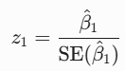
此時 z1 服從標準常態分佈 N(0, 1)
3. 決策法則（經驗法則）
在標準常態分佈中，有 95% 的機率質量集中在 [-2, 2] 的區間內（更精確地說是 ± 1.96）：
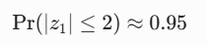
- 拒絕域： 如果我們計算出的 |z1| > 2，代表在 H0 成立的情況下，這個樣本幾乎是不可能發生的極端事件（機率小於 5%）。
- 結論： 我們有足夠的統計證據拒絕虛無假設（Reject H0$），確認該輸入變數與預測目標高度相關（例如：Balance 對預測違約非常重要）。
核心二：多元邏輯斯回歸（Multivariate Logistic Regression）
當我們同時考慮多個特徵（p > 1）時，模型會將多個特徵與其對應的係數進行線性組合，並放入 Sigmoid 函數的指數中：
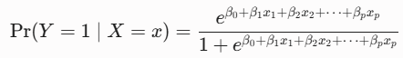
案例實戰：信用卡違約的多變數模型
在這個案例中，銀行同時納入了三個特徵：
- x1：Balance（信用卡賬戶餘額）
- x2：Income（年收入）
- x3：Student（是否為學生，這是一個類別變數，透過虛擬變數 Dummy Variable 轉換：是=1，否=0）
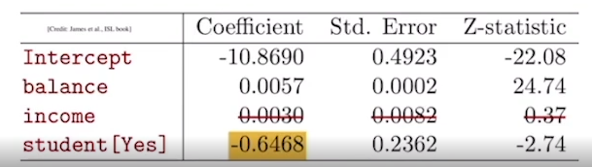
利用 MLE 估計出各變數的 hat{β} 及其標準誤差後，軟體計算出的 Z 統計量結果如下：
| 輸入特徵 (Features) | 係數估計值 (hat{β}) | 標準誤差 (SE) | Z-statistic) | 統計顯著性 (|Z| > 2) |
| Intercept (β0) | 略 | 略 | 略 | - |
| Balance (β1) | hat{β1} | SE | |Z| > 2 | 顯著（保留變數） |
| Income (β2) | hat{β2} | SE | |Z| < 2| 不顯著（無法拒絕 H0）❌ |
| Student (β3) | hat{β3} | SE | |Z| > 2 | 顯著（保留變數） |
🚨 關鍵結論與後續操作：
- 剔除不顯著變數： 由於 Income 的 |Z| 統計量小於 2，說明在控制了 Balance 和 Student 的情況下，年收入對於預測違約沒有額外的貢獻。我們無法拒絕虛無假設，因此決定將 Income 從模型中剔除。
- 係數必須重新計算： 影片最後特別強調了一個非常重要的觀念——當你決定拿掉 Income 之後，剩下的變數（Balance 和 Student）的係數「不能直接延用」舊表格裡的值。你必須用這兩個變數重新跑一次最大似然估計（MLE），重新計算出一組全新的係數。這是因為變數之間可能存在共線性或內生性，彼此會互相影響。

線性回歸（Linear Regression）用的是 t 檢定，而邏輯斯回歸（Logistic Regression）用的則是 Z 檢定。
之所以會有這個轉變，核心原因在於「殘差的假設」以及「分母（標準誤差 SE）的估計方式」不同。我們可以用以下三個關鍵點來拆解：
1. 線性回歸（Linear Regression）為什麼用 t？
線性回歸有一個經典的假設：我們假設數據的誤差項（殘差）服從常態分佈，並且它的變異數 sigma^2 是固定的。
但在實務上，我們永遠不知道真正的母體變異數 sigma^2 是多少，我們只能用手邊的樣本數據去估計出一個「樣本變異數 s^2」來代替它。
- 當你用估計的樣本標準差去標準化一個常態分佈的隨機變數時，這個變數就不再是標準常態分佈（Z）了，它會退化成 t 分佈。
- t 分佈的「肥尾（Heavy tails）」特徵，正是統計學用來懲罰「因為樣本量有限、且母體變異數未知」所帶來的額外不確定性。
2. 邏輯斯回歸（Logistic Regression）為什麼用 Z？
到了邏輯斯回歸，情況發生了根本性的改變：
- 數據本質不是常態分佈： 邏輯斯回歸的目標輸出 y 是二元標籤（0 或 1），它服從的是白努利分佈（Bernoulli distribution），而不是常態分佈。因此，它的殘差根本不可能是常態分佈，我們無法套用傳統線性回歸的 t 檢定理論。
- 變異數不需要額外估計： 白努利分佈有一個非常特殊的性質：它的變異數完全由它的機率（平均值）決定。已知機率為 p，則變異數就是 p(1-p)。在最大似然估計（MLE）的推導中，標準誤差（SE）是直接透過模型預測出的機率 hat{p} 計算出來的（透過資訊矩陣 Information Matrix），我們不需要像線性回歸那樣，額外去估計一個未知的殘差變異數 sigma^2。
3. 大樣本的「漸進常態性」（Asymptotic Normality）
既然不適用 t 檢定，那為什麼可以直接用標準常態分佈的 Z 呢？
這得歸功於統計學中的大樣本理論。邏輯斯回歸所使用的最大似然估計量（MLE）具有一個強大的數學性質：當樣本量 n 足夠大時，估計出來的參數 hat{β} 會「漸進式地」趨近於常態分佈。
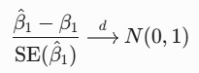
因為在大樣本下，MLE 估計出的標準誤差（SE）已經非常精確，不確定性極低，所以它直接收斂到了標準常態分佈（Z 分佈）。
💡 補充冷知識： 在許多統計軟體的輸出報表中，邏輯斯回歸的這個 Z 統計量，有時候也會被稱為 Wald statistic，它本質上就是一模一樣的東西。
總結
模型 | 依賴變數 y 的分佈 | 母體變異數是否未知？ | 檢定統計量
線性回歸 | 連續型（假設殘差為常態分佈） | 是（需透過殘差平方和估計，引入額外不確定性） | t 統計量
邏輯斯回歸 | 二元型（0/1，服從白努利分佈） | 否（變異數由機率自身決定，大樣本下漸進常態） | Z 統計量（Wald 檢定）

▶️ Logistic Regression with More Classes (2:46)
So far, we have studied logistic regression, when we have only two output classes, 0 and 1. This is what's called a binary classification setup.
Now in many scenarios, we will have K different classes where K will be in general greater than 2.
In that case, we can use a multiclass logistic regression. A multiclass logistic regression uses the following parametric shape for the conditional class probabilities. In particular, the probability that the output is equal to a label k, where k can be from 1 to capital K given the input X is equal to exponent to the power of a term that is similar to a linear regulation term. So now notice that the parameters beta have two sup indexes, in this particular case, one k.
The first index will indicate that this value of beta is weighing the first variable. And the second index k indicates that this pair is the one corresponding to the conditional class probability for class k. So in this particular case, we have beta 1 k up to beta pk, where beta pk will be weighing x of p. In the denominator, what we're going to have is a summation over all possible classes of 1 plus the same exponent that we have in the numerator.
However, this exponent will correspond to the class l that will be sum from one to capital K, meaning all the classes in our problem.
In this scenario, we can still estimate the unknown parameters, beta hats, using the maximum likelihood estimation. And this is formally equivalent to what we have seen before. Once we have the values of beta hats, we can build an estimate of the conditional class probabilities by using the conditional class probability functions defined above and substituting the values beta by beta hats.
This concludes our coverage of logistic regression, which is a technique to perform classification. Next week, we'll move on to linear discriminant analysis, which is an alternative approach for classification but before that, I suggest that you check out chapter four in our book and in particular you should read sections 4.1 up to 4.3, 4.3 included. So I'll see you next week and please work on your assignments. See you next week.
1 Attempt Quiz: Logistic Regression with More Classes

這段教材從二元分類推廣到了多元邏輯斯回歸（Multiclass Logistic Regression），也就是機器學習中常聽到的 Softmax 回歸（Softmax Regression）。這也是邏輯斯回歸技術的最高潮，為分類問題畫下了一個完美的句點。
將多元邏輯斯回歸的核心精華整理如下：
核心一：多元邏輯斯回歸的數學模型（Softmax 函數）
當總類別數 K > 2 時（例如：預測產品是「失敗」、「普通成功」還是「非常成功」），我們不能再只用一組線性組合。模型必須為每一個類別 k 都準備一組專屬的參數。
對於任意類別 k in {1, 2, …., K}，其條件機率公式為：
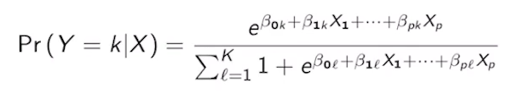老師的寫法怪怪的
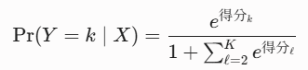
🔍 參數下標的雙重含意（以 β_{j,k} 為例）
影片中提到參數帶有兩個下標，這非常有條理：
- 第一個下標 j： 代表它是在權衡哪一個輸入特徵（特徵 xj）。
- 第二個下標 k： 代表它是屬於哪一個預測類別的專屬參數。
💡 結構設計的精妙之處（分母的歸一化）
- 分子： 算出目前類別 k 的「未歸一化得分（Logit）的指數」。得分越高，分子越大。
- 分母： 把所有可能類別的指數得分全部加起來（公式中寫作對所有類別 l 求和，並加上基準項）。
- 結果： 分子除以分母，確保了所有類別的預測機率都在 [0, 1] 之間，且所有類別的機率加總絕對等於 1。這在數學與機器學習中被稱為 Softmax 歸一化。
核心二：參數估計與預測
- 最大似然估計（MLE）： 雖然從二元變成多元，公式看起來複雜許多，但核心邏輯完全一樣。統計軟體依然是透過最大化聯合機率（或最小化多元交叉熵損失，Multiclass Cross-Entropy Loss），從既有的數據中幫我們算出每一組參數的估計值hat{β_{jk}。
- 進行預測： 當我們收到一個新樣本的特徵 x 時，只要把軟體算好的 hat{β} 填入公式，就能一口氣得到它屬於這 K 個類別的各自機率，機率最高的那個類別就是模型的最終預測。
🚀 提醒與下一步
- 課本進度： 建議閱讀經典教科書（通常指 An Introduction to Statistical Learning, ISLR）的 Chapter 4，特別是 Section 4.1 到 4.3。這幾節完美涵蓋了你目前學到的分類問題概述、邏輯斯回歸、多元邏輯斯回歸以及假設檢定。
- 下週預告： 模型將會切換到另一種截然不同的分類思維——線性判別分析（Linear Discriminant Analysis, LDA）。
💡 承前啟後的思考點：
邏輯斯回歸是直接去建模「給定 X 下 Y 的條件機率 Pr(Y | X)」（屬於判別式模型 Discriminative Model）。而下週要學的 LDA，則是先去研究「在各個類別 Y 當中，特徵 X 的分佈長怎樣 Pr(X | Y)」，再利用貝氏定理反推回來（屬於生成式模型 Generative Model）。這兩種思維的碰撞非常有趣！

---
為什麼公式裡會塞一個神祕的 1？
在二元分類中，我們知道只要算出 p1(x)，那 p0(x) 自然就是 1 - p1(x)。換句話說，我們只需要設定一組參數來預測類別 1 就夠了，不需要幫類別 0 也設一組參數。
多元分類（共有 K 個類別）也是完全一樣的道理。如果我們知道前 K-1 個類別的機率，那最後一個類別的機率自然就確定了。
因此，教科書通常會把某一個類別（通常是最後一個類別 K，或者第一個類別 1）當作基準點（Baseline），並強行把該基準類別的係數都設為 0。
如果我們把最後一個類別 K 當作基準點：
- 類別 K 的線性得分為 0，所以它的指數項為 e^0 = 1。
- 其他類別 k（從 1 到 K-1）的得分則是正常的 e^{β_{0k} + β_{1k}∙x}
當我們把所有類別的得分加起來當作分母時，分母就會長這樣：
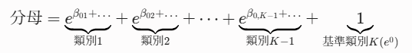
這就是你看到的公式中，分母那個神祕的 1 的由來！它其實代表的是基準類別自己的得分。

數學證明：所有類別機率加總
既然知道了這個 1 的本質，我們把所有類別的機率通通加起來看看。
假設總共有 3 個類別（K=3），我們把類別 3 當作基準點（得分的指數項為 1）：
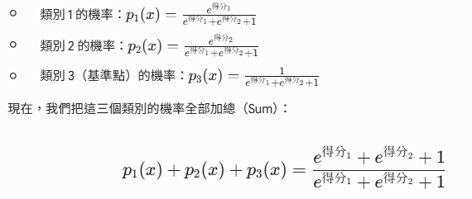

電腦與機器學習中的另一種對稱寫法
你可能在其他機器學習（例如深度學習的 Softmax）課本看過另一種沒有 1 的寫法：
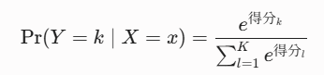
在這種寫法裡，分母直接從 1 連加到 K，沒有那個單獨的 1。
- 為什麼這兩種寫法都能用？
因為如果我們把第二種寫法的分子和分母，同時除以最後一項 e^{得分_K}，分母的最後一項就無縫變形回你課本上看到的、帶有 1 的公式了。
總結
課本公式分母裡的那個 1，並不是一個孤立的常數，它其實是「某個被選為基準的類別的機率分子」。當你把所有類別（包含那個基準類別）的機率全部加起來時，那個 1 就會被打包收進分子的加總裡，讓分子分母完全相等，從而確保總和為 1！

4. Python Lab
▶️ Python Lab: Logistic Regression (18:23)
Lab 4 Materials
Hello, everybody. Welcome to recitation 4 part 1. In these next two recitations, we'll be looking at predicting categorical variables given continuous or categorical features. In this recitation, we'll be covering logistic regression, hypothesis testing in logistic regression, constructing a classifier, and multiple logistic regression. So in this example, we can see that we will have trouble if we try to perform linear regression to predict color. We could encode each different color into an integer value and perform linear regression that way. But as we will see later, this will result in a lot of problems in our analysis.
We'll be performing our first logistic regression on stock market data using the S market data set. This data set contains information for the S&P 500 stock over 1,250 days. This data has been transformed such that each row contains the columns lag 1 through lag 5, which is the percentage returns of the previous five days, and additionally contains a column volume, which is the number of shares traded on the previous day in billions. Column today, which is a percentage return on the date in question, and direction, which is whether the market went up or down on the state. Now, let's look at our imported libraries. So here, take note of classification stats, logistic linear regression, and LDA will be used in the next recitation. So for classification stats, you will be using sm and smf to conduct logistic regression as well as logistic regression and linear regression when we want to conduct linear regression. Classification report and confusion matrix will be used in the next recitation.
So now, let's read in our data set and preview it, then let's drop the unnamed zero column, because that is just redundant information. We can also get statistical information about the data set using data.describe. So notice that all these stats apply to each column.
In addition, we can get the pairwise correlation of each feature using data.corr.
A matrix of pairwise scatter plots can be obtained using pd.plotting.scatter_matrix.
Unsurprisingly, we see that there's pretty much no correlation between any of the features. The only slight correlation that we can see is that as we increase in year, volume tends to slightly increase.
Now, let's fit a logistic regression model in order to predict direction using lag 1 through lag 5 and volume. To do this, we first need to encode a qualitative variable direction into a binary one for up and zero for down. This can be easily accomplished using Lambda expressions. Lambda expressions are simply one line functions without a name. The syntax is that you write Lambda, then your input variable, colon, and the expression to this one line function returns after the colon. These are convenient for passing into functions. Note that in Python, any iterable, such as a column and a panel or data frame can be mapped to a new iterable by passing in a function that maps each individual element to a new element. In this example, we pass in our Lambda expression encode. Note that we could have additionally defined a new function encode like this, and then just returned this expression, which will have the identical effect as our Lambda expression.
So now let's preview our data again, you can see here direction now only consist of binary ones and zeros.
Now, to perform the logistic regression, we use the GLM method for stats models, which stands for generalized linear model. To do so, we call smf.glm, and we pass in a formula string of the form of y column variable name, tilde or x column variable names added together, then we pass in our data. Then we set family equal to sm.family.binomial, close parentheses. Then to perform the regression, we call dot fit. This is what our summary looks like. Note that if we did not encode the direction variable ourselves, that GLM will have automatically encoded the first occurrence as one and the rest as zero. It's good idea to encode it yourself so that you know which one is one and which one is zero. Looking at our summary, we can see or Beta_0 coefficient, our Beta_1 through Beta_6 coefficient and the Z statistic, as well as the confidence interval.
Lastly, we can make predictions using the predict function. It's going to be easily done by calling fit1.predict. If we do not pass in any arguments, it will simply return the probabilities of each row of the training data. We will now move on to the default dataset, confusion matrix and making training and test data as well as linear discriminant analysis will be covered in next recitation.
QDA and K-nearest neighbors will not be covered in these recitations. We will now go further in depth into logistic regression using the default dataset. Note that there are multiple categorical variables including default and student.
We encode student using a Lambda function as done previously, and we encode default using list comprehension. A cleaner way to use lists comprehension in my opinion, is with the following expression.
However, you can use whichever method you please. Now let's preview our data, data.head, and we see that the categorical variables have been properly translated. So our goal here is to predict if a given person defaults, given if that person is a student, their balance and their income. Linear regression will now work here because it can predict values outside of the range zero and one. Logistic regression, however, achieves what we are looking for by predicting probabilities that a person defaults given the input data. Let's look at an example using linear regression. Here we obtain a numpy array of our pandas data frame with the.values attribute. Then we reshape the second column to have the shape and common one, where n is the length of data. We reshape the fourth column the same way, and then we perform linear regression on these two new vectors.
As we can see here, our linear regression model shown in red, does not accurately capture the relationship between balance and default. For one, our linear regression model predicts each bounds to have a default value of less than one. It predicts some of them to have a negative default value. Even if we were to interpret these as probabilities, still does not make sense because a negative probability has no meaning, and it will classify each default value for each point as zero. Now let's fit a logistic regression model instead.
Once again, the goal of logistic regression is to predict the probability that a default is equal to yes, given a balance. Since we are predicting probabilities, we need to choose a function that will limit the range of our output to the interval 0-1 inclusive. We're going to be using the logistic function for that, which has the form in this expression. Note that it is parameterized by Beta naught and Beta 1 similar to linear regression. Additionally, note that the probability that a default is no given the same balance is one minus the probability that the default is yes given the balance. We can also interpret Beta naught plus Beta 1 times our balance as the log odds ratio.
Just like linear regression, our goal is to estimate the values of Beta naught and Beta 1, and this is achieved using the maximum likelihood estimator. However, unlike linear regression, in which case these values can be computed for matrix operations of our data, there is no closed form solution. Once again, we use smf.glm and pass in a formula string to perform a logistic regression, and we get the following summary. We see here that our Beta naught is negative 10.6513 and our Beta 1 is 0.0055. We cannot interpret these results as easily as linear regression because the relationship between the probabilities and the coefficients is nonlinear because of the logistic function. However, we can interpret the sign because Beta 1 is positive, this means that an increase imbalance will lead to an increase in the probability that a given person is a defaulter.
We can now model the relationship between balance and probability of being a defaulter using this scatter plot. We see that every value of balance greater than about 1,800 has a probability of default greater than 0.5. and here we plot the log odds, which is our linear function, Beta naught plus Beta 1 times balance.
Now that we have learned a Beta naught, a Beta 1 can easily make predictions by simply plugging in Beta naught and Beta 1 to our logistic function as well as our balance, in this example, we plug in our negative 10.65 Beta naught and our 0.00. Zero five five Beta one and a balance of 2,000 to our logistic function which predicts a probability of 0.5863 of defaulting. To do this in code, we simply create a new DataFrame and set the balance equal to 2,000. Note that this can be an array of values if you want to predict multiple values at once. To obtain the prediction, we simply call fit1.predict pass our new DataFrame, obtain a 0 with element because we only passed in one element for balance. Now we move on to confidence intervals and hypothesis testing. Recall that we can obtain our 95 percent confidence interval for each Beta in the summary statistics. In addition, we can obtain our z statistics from the summary statistics. Let's go take a look.
Here we see both of our z statistics have an absolute value of greater than two. This means that we reject the null hypothesis that Beta is equal to zero with 95 percent confidence. If either of the absolute value of the z statistics were less than two, then we would fail to reject the null hypothesis for the Beta of consideration.
We will not be covering ANOVA tests or P values in this course, or Chi-squared tests.
Now we see three examples of how to construct a classifier from the learn model. The standard classifier, which we'll call majority vote, is to classifying instance as yes, if the probability of yes is greater than 0.5 and no otherwise. A more conservative position from the bank's perspective would be to classify all instances as yes for defaulting, but the probability of defaulting is greater than 0.2. A more lenient position from the bank's perspective is to classify an instance as defaulting only if the probability of defaulting is greater than 0.8.
Note that we can rate our majority vote classifier as this inequality. By manipulating both sides, we see we will always classify a person to Yes, if their balance is greater than 1936.6.
The X cutoffs for these three classifiers can be computed in Python as seen right here.
Now we can use matplotlib.subplot and sns.stripplot to plot all of our points as well of the cutoffs. I'll not go over specifically how to do this, but the general pattern can be seen right here.
Note that the probability of defaulting for a given balance can be seen as the number of orange dots divided by the number of total dots for a given balance. The majority vote classifier, we see that on the left of this black bar, this ratio is less than 0.5, and on the right of this black bar is greater than 0.5.
This should actually say lenient classifier because the black bar has shifted right, and we can see that it requires a higher probability to classify a person as a defaulter. Here is the conservative classifier mislabeled above, and we can see that the black bar is shifted left, which means that it requires a lower probability of a person defaulting to classify it as defaulting.
We will cover metrics for classifiers in the next recitation.
Lastly, we go over another example of how to perform multiple logistic regression. Once again, this can be done by passing in a formula string of the form y colon name tilde, x colon names added together and pass in our data instead of family to sm.families.Binomial and calling.fit. Our summary statistic can be seen below.
Note that with multiple dependent variables, we see that an increase in balance still leads to an increase in the probability of default. Being a student, however, leads to a decrease in the probability because of the negative sign. Note that the probability that a default equals Yes, given a balance, takes the form of this expression.
One final note is performing logistic regression with sklearn. Here we obtain an x vector from the first to the last columns, and our y vector is the first column. Then we define a logistic regression model called.fit passing our X and y. To obtain predictions for an array such as our training data X, we call logregr.predict. This will implement a majority vote classifier. To obtain the probabilities that a default is equal to Yes, with any X numpy array. We call logregr.predict and pass in predict proba and passing our X. The classification report will be covered in next recitation.

Logistic Regression 在 Python 中的實際操作（利用 statsmodels 和 sklearn）、統計圖表解讀，以及分類器門檻的商業邏輯（保守 vs 寬容）完整串聯了起來。
這段長文精煉成「程式實戰操作」、「統計模型解讀」與「分類決策門檻」三大核心區塊：
核心一：Python 實戰代碼與資料預處理
在進入模型前，必須先進行特徵工程與格式轉換。
1. 類別變數轉二元編碼（Encoding）
文字提到兩種在 Python 中將「Yes/Up to 1」和「No/Down to 0」的優雅寫法：
- 方法 A：Lambda 表達式（無名函數）
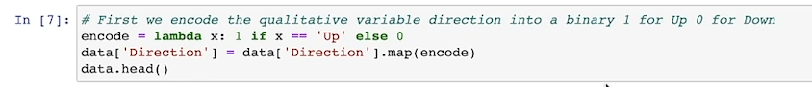
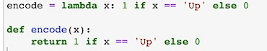 這是等價的
- 方法 B：列表推導式（List Comprehension）
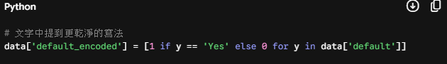
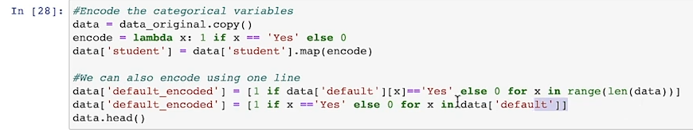

2. 兩種套件的模型擬合（Fitting）
- Statsmodels (GLM 模式)： 適合用來做統計分析、看詳細報表（Z 檢定、信賴區間）。
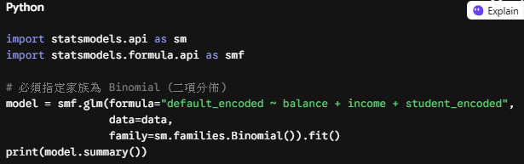
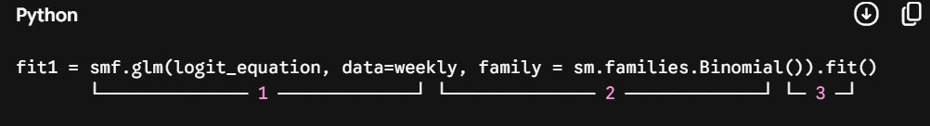
1. smf.glm(logit_equation, data=weekly, ...)：設定模型結構與資料
- smf.glm：GLM 代表 Generalized Linear Model（廣義線性模型）。邏輯斯迴歸其實就是廣義線性模型的一種特例。
- logit_equation：這就是你前面設定的公式字串 'Direction ~ Lag1 + Lag2 + Lag3 + Lag4 + Lag5'。它告訴模型：「我想用 Lag1 到 Lag5 這五個過去的報酬率（自變數 X），來預測股市未來的方向 Direction（應變數 Y）」。
- data=weekly：指定模型要使用的資料來源，就是我們讀進來的 weekly 這個 DataFrame 表格。
2. family = sm.families.Binomial()：指定「邏輯斯迴歸」模型
這是最關鍵的數學設定！廣義線性模型（GLM）可以延伸出很多種不同的預測模型（例如預測數值的線性迴歸、預測次數的卜瓦松迴歸等）。
- Binomial()（二項分佈）：我們明確告訴 Python，我們的目標變數 Direction 只有兩種可能：1（上漲）或 0（下跌）。
- 當你指定 family = sm.families.Binomial() 時，statsmodels 就會啟動邏輯斯迴歸（Logistic Regression）的數學機制，使用 Sigmoid 函數將預測值壓縮到 0 到 1 之間，用來代表「上漲的機率」。
3. .fit()：動手進行數學計算（訓練模型）
前面設定好了公式、資料和模型種類，但這時候模型還只是一張「藍圖」，裡面各個變數的係數（Coefficients, 也就是 β 權重）都還沒算出來。
- 呼叫 .fit() 的那一刻，Python 就會正式把 weekly 的 1,089 筆數據倒進去這個模型裡，利用數學上的最大概似估計法（Maximum Likelihood Estimation, MLE）去瘋狂計算，找出最能解釋這 21 年股市漲跌規律的係數。
最終，計算出來的所有精華結果（包含每個變數的係數、P-value、顯著性等統計資訊），都會被打包存進 fit1 這個變數物件中。

- Scikit-Learn (Sklearn)： 適合用來做機器學習流程、快速預測與封裝。
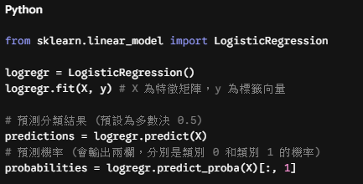
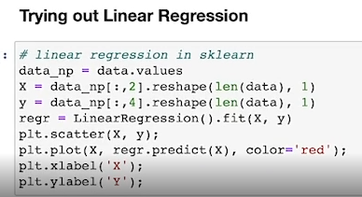
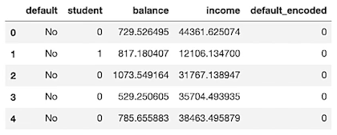
- data.values：把 Pandas 的 DataFrame 表格轉換成純數字的 NumPy 陣列（Array），方便進行高效的數學矩陣運算。
- data_np[:, 2]：取出所有資料的第 3 欄（Python 索引從 0 開始算：0, 1, 2），當作我們的自變數 X（特徵值）。這就是balance
- data_np[:, 4]：取出所有資料的第 5 欄(這就是default_encoded)，當作我們的應變數 y（想要預測的目標值）。
- .reshape(len(data), 1) 為什麼要用這個？
- 關鍵原因：sklearn 的模型有一個硬性規定，傳入的特徵值 X 必須是二維矩陣（有列也有行，像表格一樣）。
- 剛切出來的 data_np[:, 2] 原本只是一條一維的「數字清單」，經過 .reshape(..., 1) 之後，就會被強行轉換成一個「長條狀的二維矩陣（N 列 x 1 行）」。這樣模型才肯收件。

核心二：統計報表解讀與數學本質
1. 為什麼不能用線性回歸（OLS）預測機率？
如文字中所做的實驗，線性回歸（紅線）會預測出小於 0 或大於 1 的不合理數值。在統計上，這使得機率與分類失去實質意義；而邏輯斯回歸透過 Sigmoid 函數將輸出完美鎖定在 [0, 1] 區間。
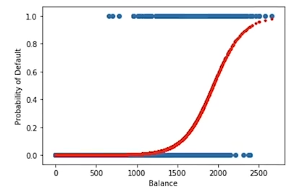
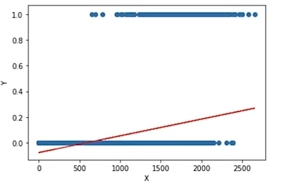

2. 多元邏輯斯回歸公式
當我們同時納入多個變數時，其條件機率公式為：
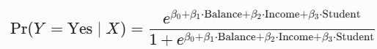

3. 正負號的直覺解讀
在邏輯斯模型中，因為外層套了非線性函數，我們無法直接像線性回歸那樣說「特徵增加 1，機率就增加 β1」。但我們可以透過正負號來判斷趨勢方向：
- Balance (β1 > 0)： 係數為正，代表隨著帳戶餘額增加，違約機率會顯著上升。
- Student (β3 < 0)： 係數為負，代表在其他條件相同下，學生身份反而會降低違約機率。
4. 假設檢定（Z-statistic）
報表中提供的 Z 統計量（Z-statistic = Coefficient / Standard Error），只要其絕對值大於 2，我們就可以在 95% 的信心水準下拒絕虛無假設（Reject H0: β=0），確認該特徵具備顯著預測能力。
註：文中提到本課程不涵蓋 ANOVA、P-values 或卡方檢定。

核心三：商業決策與分類器門檻（Thresholds）
得到模型預測的「機率」後，銀行可以根據自身的風險承受度，主動調整分類器的切分邊界（Cut-off）：
分類器策略 | 機率門檻 (Threshold) | 實務商業邏輯 | 邊界平移效應
多數決 classifier  (Majority Vote) | > 0.5 違約 | 標準模型。數學上可以反解出：當 Balance > 1936.6時，模型即預測其會違約。 | 基準線
保守型 classifier  (Conservative) | > 0.2 違約 | 銀行寧願錯殺一百，也不願放過一個。 只要客戶有 20% 的機率會違約，就認定他是危險客戶。 | 黑條左移： 抓出更多潛在違約者，但會提高偽陽性（誤判好人）。
寬容型 classifier  (Lenient) | > 0.8 違約 | 銀行心臟很大。 除非客戶有高達 80% 的機率會違約，否則一律視為安全。 | 黑條右移： 放寬貸款授信，但可能會漏掉真正的違約高風險者。
📅 下堂課進度預告
混淆矩陣（Confusion Matrix）、測試集拆分（Train/Test Split）以及線性判別分析（LDA），將會是下一堂 Recitation 的核心主題。

statsmodels寫法
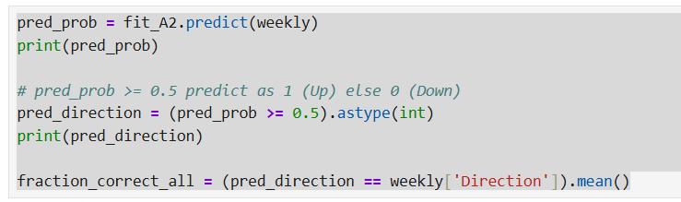

這是sklearn的寫法 跟statsmodels寫法有些不同



